L2 or L3 or tests name: Bonus & Salary Process Staff without Risk Taker (staff L1-L4, 5 and 5*)
Staff level 5 and 5* Non-RT for DBAG, EFAG, ECAG, ExR covered in Merit process board members and executives
Legal entities in scope: DBAG/CBL/ECAG/CBF/CH/LuxCSD/CS/CI/CFCL/ExR/EFAG
Test(s) according to RCA:
Control design effectiveness
1.Review relevant policies and procedures to identify key requirements, process steps and controls
2.Validate that merit rules are in line with relevant policies, procedures and guidelines
3.FuN 241119104921: By 7 June 2026 all the companies in Europe must comply with the "Directive (EU) 2023/970 of the European Parliament and of the Council of 10 May 2023 to strengthen the application of the principle of equal pay for equal work or work of equal value between men and women through pay transparency and enforcement mechanisms (Text with EEA relevance)". How are we preparing to be compliant? https://eur-lex.europa.eu/EN/legal-content/summary/equal-pay-for-equal-work-or-work-of-equal-value-between-men-and-women-rules-on-pay-transparency.html
4. In the context of the gender parity and pay equity, inquire how is this covered in the applicable policies in place

Control operating effectiveness
1.On a sample basis, validate that:
- Controls are executed and adequately documented
- Relevant data is uploaded in the tool
- Bonus calculation and accruals are accurate
- Bonus amounts in merit letters are in line with amounts sent to Payroll, accruals and decision documents

IT applications:
AID154 SAP ERP, AID2077 MPLEO, AID 0306 SAP SuccessFactors, AID2157 PayAnalytics
1. For the above applications, review the security documentation and ensure same is up to date
2. Ensure roles and access rights are defined and there are no conflicting roles
3. Ensure SoD is respected
4. For AID2077, obtain migration and decommissioning concepts and review the completeness of the migrated functionality and data to the new system For AID2077, obtain the decommissioning documentation and review same

Risk:
B7 Reputational Risk;
B12 Vendor Dependency Risk;
O1 Regulatory Compliance Risk;
O2 Other Compliance Risk;
O5 Criminal Offence (incl. Fraud) Risk;
O7 Privacy Risk;
O12 Internal Information Security Risk;
O19 Private Settlement & Litigation Risk;
O25 Human Error Risk;
O28 Processing and Execution Risk;
O31 Secondary Reputational Risk;
O32 In-/Outsourcing and External Procurements Risk;
O33 Third Party Compliance Risk

Merit Review process is used to integrate wrong payments to internal or external people

Conclusion: OK/no issues identified
1 audit comment for CoL: Potential for SAP SuccessFactors tool enhancement

Audit procedures/source:
Internal audit (AK) has performed the following Audit procedures:
- Inquiry: Held interviews with responsible stakeholders
- Kerstin Rau, VP Rewards, Regulation & Frameworks (S)
- Nicole Dittrich, VP Rewards, Regulation & Frameworks (S)
- Christoph Bosler, VP Rewards, Regulation & Frameworks (S)
- Vera Jordan, Director HR Business Partner, HR Global Business Partner (Dpt)
- Erion Pagio, Senior Associate Vice President | HR Business Partner, HR Luxembourg (U)
- Alexandra Zell, Vice President | Head of HR Services Luxembourg, HR Services Luxembourg (U)
- Inspection: Of policies and evidences
- Sampling – annual controls 1 sample, bonus amount plausibility check on a sample of 10 employees

Procedures / Criteria / documents used
- Regulation (EU) No 2019/876, also known as CRR II
- Directive 2019/878/EU, also known as CRD V
- Commission Delegated Regulation (EU) 2021/923 of 25 March 2021
- Law of 5 April 1993 on the financial sector
- CIRCULAR CSSF 10/437
- Circular CSSF 22/797
- MaRisk 4.3.2, BT 3.2, BT3.3 and BT 3.4
- Minimum Wage Act (Germany)
- General Equal Treatment Act (AGG)
- Protection Against Unfair Dismissal Act
- Remuneration Policy Clearstream Group (CH CBF)
- Remuneration Policy Clearstream Group Lux (CBL CI CS)
- Remuneration Policy ECAG
- Remuneration Policy Eurex Repo
- Remuneration Policy LuxCSD
- Remuneration Policy CFCL
- Bonus Salary Process Staff without Risk Taker

Work Done:
Control Design Effectiveness
1.Review relevant policies and procedures to identify key requirements, process steps and controls

IA reviewed the process in place and held a walkthrough meeting
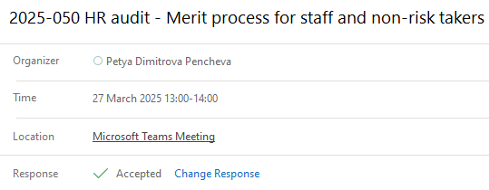
Notes from the meeting and several follow-up questions are captured in the process document 3.1 Bonus Salary Process Staff without Risk Taker (1).docx
Auditee’s feedback available directly in the document 00_3.1 Bonus Salary Process Staff without Risk Taker (1)_CB_Feedback.docx

IA identified 7 controls relevant for staff merit process:
- 3 controls in responsibility of Rewards, Regulation & Frameworks (RRF)
- 1 control in responsibility of Compensation Officer Team
- 1 control in responsibility of Compensation Planner/employee’s Line Manager
- 2 controls in responsibility of HR Officer (Business Partner, Global Service)/HRO

Control description is consistent in process documentation, please refer to analysis in Merit staff controls.xlsx

All controls are based on organisational 4ep. Control implementation should be documented via checklist, screenshots, sign-off, emails.
Controls are performed manually outside of the SF tool. Relevant calculations are downloaded from the tool, checks and recalculations are performed in excel. This causes process inefficiency and enhances the risk of undetected errors.
IA is of the opinion that an enhancement of the tool and automation of controls will be beneficial as it will increase the process efficiency, optimize control execution and further reduce the possibility of errors occurring.

Conclusion: OK, but there is potential for process improvement. Automation of controls within SAP SuccessFactor tool would increase process efficiency and control effectiveness. To be raised as Audit Comment.

2.Validate that merit rules are in line with relevant policies, procedures and guidelines

Merit rules are stipulated in remuneration policies and Merit Guidance documents that serve as guidance for line managers.
Per process requirements, Merit Guidance documents are aligned for potential update with
- Compensation Officer Step_01_CompOfficer_Feedback.pdf
- HRO Step_03 HRO-Pre-information inkl. Fx-rate Info.pdf
- Workers Council Germany: Step_02_b Alignment wit workers council Germany.pdf, Step_02_a Alignment wit workers council Germany.pdf only for German LEs
Remuneration policies general rules applicable for all regulated LEs:
- For staff Non-RT discretionary variable remuneration is determined; additionally collective agreements may apply depending on the location
- Variable remuneration can amount between 0-100% of fixed remuneration. Negative deviations of agreed goals (on individual level, including the area of responsibility), Breach of Duty and Unconscionable Conduct shall lead to a reduction of up to 100% of the Variable Remuneration (100% means no award of Variable Remuneration). The reduction shall not be compensated by positive Performance Contributions.
- Up to max of 200% of fixed remuneration if approved by the shareholders, owners or members of the institution
- A mix of Fixed and Variable Remuneration for employees in Control Units should be weighted in favour of Fixed Remuneration. A Fixed Remuneration only is permissible. In principle, the Variable Remuneration shall not exceed one third of the total Remuneration. This ratio can be exceeded only in exceptional well-justified situations, but the Variable Remuneration shall in any case be below the Fixed Remuneration. (not applicable for ExR)

CBF, CH guidance | CBL, CFCL guidance | DBAG and EUREX guidance
 |  | Budgeting depends on the individual, annual fixed salary – 10,20 or 30% of fixed salary depending on the salary amount/range
the variable remuneration for employees in control units shall not exceed one third of the total remuneration (equals to 50% of fix)
In case of significant negative performance contributions or serious infringements it must be checked whether this would lead to a reduction of the computational proposal value. For further information, please refer to the respective Remuneration Policy.
Bonus is pro rata for staff that joined the company between January1st, 2024 and December 31st, 2024. | Bonus is pro-rated for eligible staff that joined the company up to October 1st, 2024. | Bonus is pro rata for staff that joined the company between January1st, 2024 and December 31st, 2024.
For such staff, please be sure to indicate the pro-rata amount as shown in column “Actual Bonus Proposal”. The pro-rata amount will automatically be calculated for the whole year under “Fulltime Bonus Proposal”.
Staff who leave the company due to a time limit may receive a variable bonus if they are still employed till the end of 2024. |  | Staff who leave the company due to a time limit may receive a variable bonus if they are still employed till the end of 2024.
For time periods where the staff were not entitled to a salary or to wage-compensating benefits (e.g. parental leave), and/or employees working part-time, the bonus needs to be entered as pro-rata amount. The fulltime amount will be shown automatically in a separate field.
 | where a 'Loyalty Bonus', 'June Premium' or similar benefit has to be paid out in 2025 according to the Collective Bargaining Agreement for the banking sector, the related amount has already been included in, and covered by, the March total bonus payment. No further bonus payment shall be executed in and for 2025. The sum of the Performance bonus and the Loyalty bonus are included in the column “Actual Bonus Proposal”, in the tool

Guidelines in Step_04_01_Staff Merit 2024_Quick Start Guide_vf.pdf

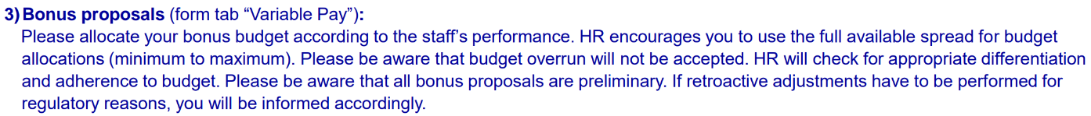
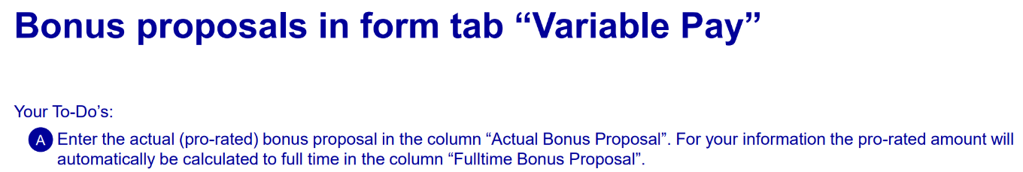

Conclusion: OK, merit rules in the guidance documents and merit tool guideline are in line with applicable remuneration policies.

3.FuN 241119104921: By 7 June 2026 all the companies in Europe must comply with the "Directive (EU) 2023/970 of the European Parliament and of the Council of 10 May 2023 to strengthen the application of the principle of equal pay for equal work or work of equal value between men and women through pay transparency and enforcement mechanisms (Text with EEA relevance)". How are we preparing to be compliant? https://eur-lex.europa.eu/EN/legal-content/summary/equal-pay-for-equal-work-or-work-of-equal-value-between-men-and-women-rules-on-pay-transparency.html

IA inquired on the status, action plan and upcoming changes
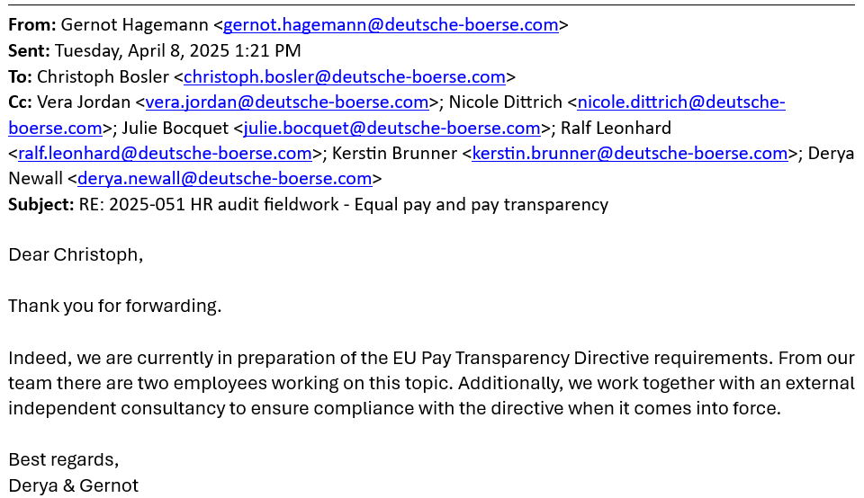


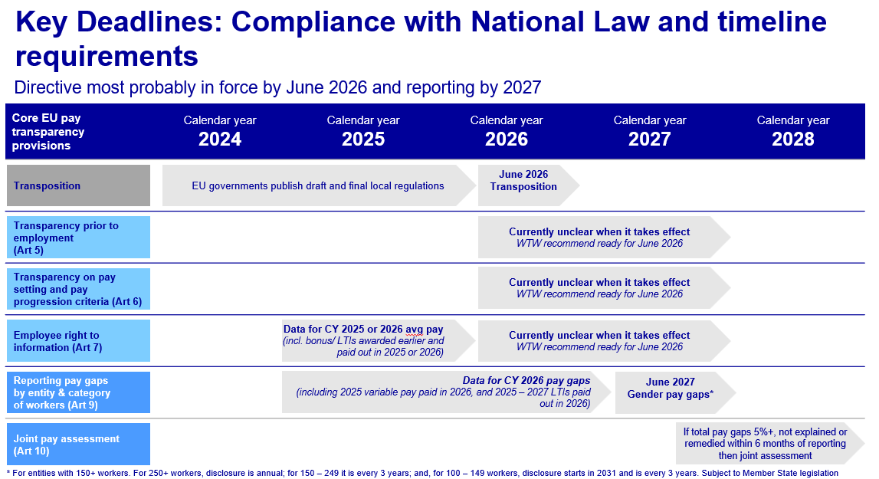

Conclusion: OK, preparation on track

4. In the context of the gender parity and pay equity, inquire how is this covered in the applicable policies in place

Six remuneration policies in place are gender neutral. Policies set out principles of appropriate remuneration:
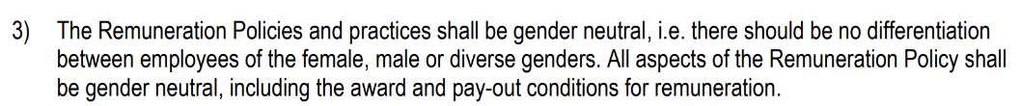

Also, circumvention, as the non-compliance with Remuneration requirements takes place in the following circumstances (remuneration policies for ECAG and Clearstream entities):

Conclusion: OK, applicable policies are gender neutral

Control Operating Effectiveness
1.On a sample basis, validate that:
- Controls are executed and adequately documented
- Relevant data is uploaded in the tool
- Bonus calculation and accruals are accurate
- Bonus amounts in merit letters are in line with amounts sent to Payroll, accruals and decision documents

Controls are executed annually, therefore sample size is 1 for 2024. Evidence and conclusion available in Merit staff controls.xlsx OK, controls executed as designed

DBG ExBo decisions on bonus amount and pay-out ratio for staff – NO CHANGE
November 2024 – preliminary KPI achievements
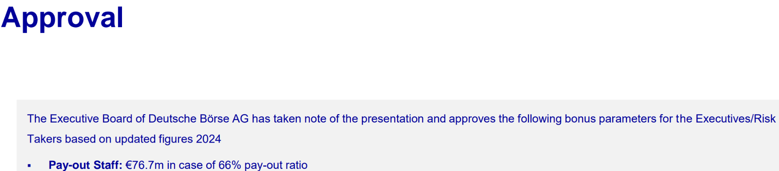

January 2025 - final KPI achievements
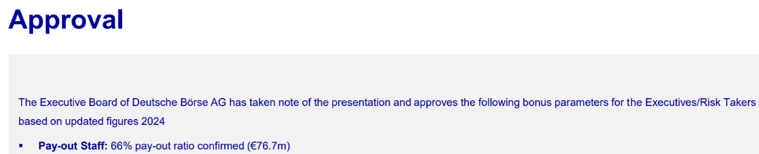

Regulated LEs ExBo decisions on Preliminary Total Amount of Variable Remuneration 2024 - determined a payout ratio of 66% with a corresponding allocated amounts variable remuneration 2024 for staff (non Risk Takers) for preliminary payout
Step_24_20240218 CBL ExBo Prel Total Amount v2.pdf – 9,17 Mio EUR
Step_24_20250213 CH ExBo prel TAM v02.pdf – 0,28 Mio EUR
Step_24_20250219 CFCL ExBo Prel Total Amount.pdf – 5,24 Mio EUR
Step_24_20250219 ECAG ExBo Prel TAM v1.1.pdf – 4,3 Mio EUR
Step_24_20250221 CI ComEx Prel TAM Staff.pdf – 0,13 Mio EUR
Step_24_20250224 CBF ExBo Prel Total Amount v1.pdf – 4,76 Mio EUR
Step_24_20250225 CS ExBo Prel Total Amount v2.pdf – 10 Mio EUR
Step_24_20250225 LuxCSD ComEx prel payout staff v1.pdf – 0,09 Mio EUR
Total excluding DBAG, EFAG, ExR – 33,97 Mio EUR

Process step 5. Preparation of normed data basis with regard to bonus claims, which serves as a 100%-basis for determining the bonus accruals and the bonus budget – prepared in SSF checked in excel
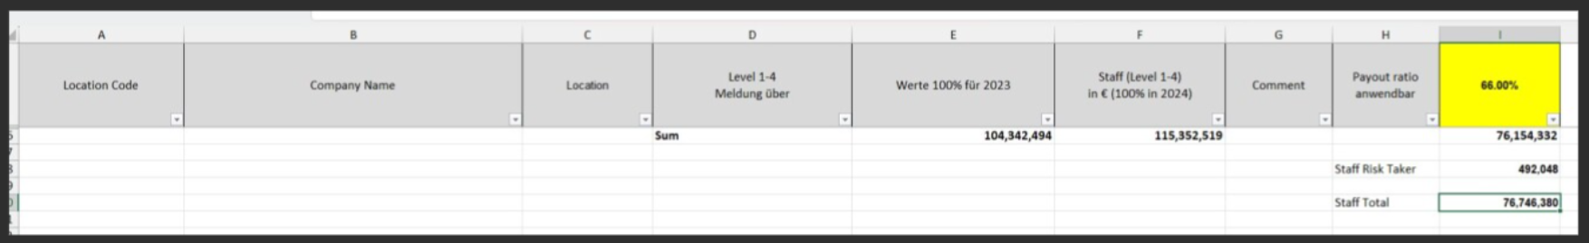

Bonus budget calculation is checked several times throughout the process
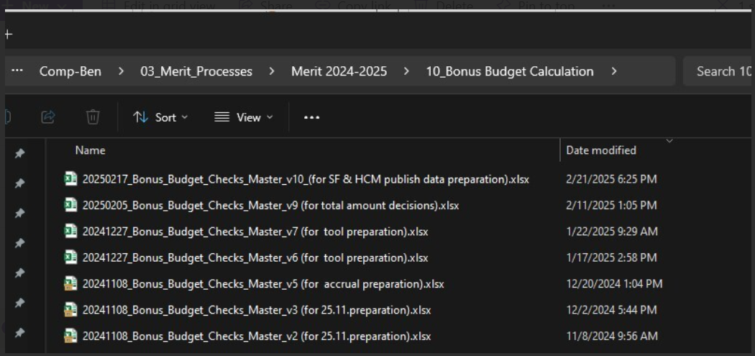

Exchange rates – relevant for other locations (out of audit scope)
Step_03 HRO-Pre-information inkl. Fx-rate Info.pdf
Step_03&05_Currency_1 Oct 2024.xlsx

Bonus calculations are done in the tool and checked by RRF team in excel-recalculation. IA confirmed that relevant data is available in the tool via screensharing on a meeting held on 9. April 2025. Excel calculations were also presented on a call.
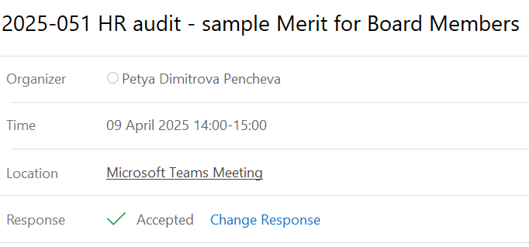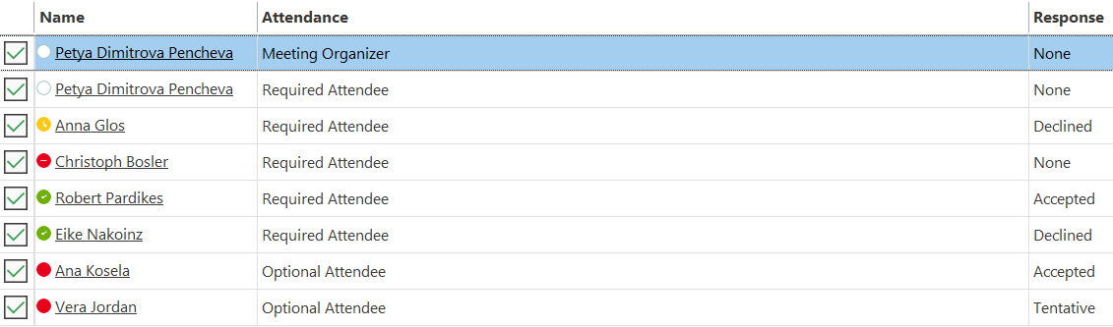

Bonus amounts alignment and accuracy is tested on a sample of 10 employees selected from an anonymized list of employees level 1-4.

Bonus sample testing.xlsx with conclusion.

Conclusion: OK, no issues identified

IT applications:
AID154 SAP ERP, AID2077 MPLEO, AID 0306 SAP SuccessFactors, AID2157 PayAnalytics
1. For the above applications, review the security documentation and ensure same is up to date
2. Ensure roles and access rights are defined and there are no conflicting roles
3. Ensure SoD is respected
4. For AID2077, obtain migration and decommissioning concepts and review the completeness of the migrated functionality and data to the new system For AID2077, obtain the decommissioning documentation and review same

For results, please refer to separate working paper: link the wp

